1. **Implement the following using SASS**
   * **Use the HTML code from homework.html**
     + **Create the SASS easy to change (backgrounds, fonts)**
     + **Use mixins for clears, gradients)**

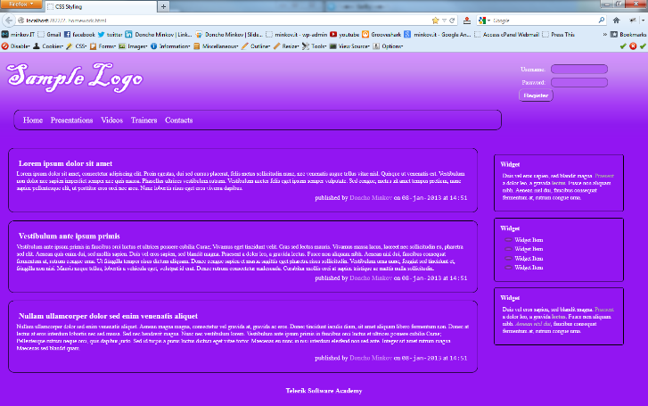

1. **Create a web gallery**
   * **Use only HTML, SASS and CSS**
   * **List images**
   * **When a image is selected, show it zoomed**

